|  |  |
| --- | --- |
| **Student Name** | Kimeu Dominic Kiio |
| **Student Number** | P15/142580/2021 |
| **Supervisor Name** | Dr. Kahonge Andrew M. |
| **Project Title** | GEOGRAPHIC SPECIFIC EMERGENCY BROADCAST OVER MOBILE CARRIER NETWORKS |
| **Year** | 2022/2023 |

PROJECT PROPOSAL

PROJECT OVERVIEW

Having the ability to quickly and efficiently send emergency alerts to the general public in multiple scenarios is an indispensable asset. The systems currently in place are: breaking news, social media, and public address systems. These systems fall short when the timeliness of delivering the message is of great concern.

Currently, there is no system that can quickly dispense information in near-real time. Despite this, a 2020-2021 report conducted by the Communications Authority of Kenya (CAK) showed that there were 64,205,721 active mobile telephony subscriptions at the end of 2021 ***(“Communications Authority of Kenya Annual Report and Financial Statements 2020-2021,” n.d.).*** According to the same report, only less than 3.4% of the population have zero access to 2G networks while attaining 96.6% population coverage. The total geographical coverage is at 56.5%.

Hence with this almost complete population coverage, utilizing mobile carrier networks to send Short Messaging Service-Cell Broadcast (SMS-CB) messages will enable the relevant parties to reach the mobile users in a defined area at the same time. The relevant parties being: law enforcement, the fire brigade, weather forecasters, medical practitioners etc.

Unlike a normal SMS-PP which is peer to peer, Cell Broadcast (CB) is a one to many geo-targeted and geo-fenced messaging service. SMS-CB messages are directed to base station radio cells or multiple bases stations rather than specific telephones. This maintains recipient anonymity whilst reaching the intended recipients in a given area or zone. Once a CB message is initiated, it can be repeated indefinitely. The recipients that have already received it can simply discard the message because it maintains a list of the serial numbers of received CB messages. This allows for recipients moving into the zone or whose connection was down to be able to receive the message for as long as the CB message is repeated.

PROJECT OBJECTIVES

The objective will be to create a simulation of such an environment as shown above using a client-server model. This will be done by creating a mobile application that acts as a mobile user, and the server which is the base station controller and base station defining zones and maintain client connections. Hence the objectives are as follows:

1. Define senders.
2. Define receivers.
3. Create base stations with broadcast zones divided into cells.
4. Manage client connections to base stations.
5. Send broadcast messages.
6. Receive broadcast messages.
7. Create filter parameters for targeted broadcast messages.
8. Manage receiver messages.

RESEARCH OBJECTIVES

* Research on the impact timely communication in the success of responding and dealing with emergency situations.
* Research on how mobile carrier networks communicate with connected clients and deal with handovers.

SYSTEM DEVELOPMENT OBJECTIVES

* **Requirements Gathering**

Gathering the necessary information to create functionality that the system will support.

* **System Design**

Taking time to develop the top overview of the system and how the multiple components and subsystems will work together.

* **Coding**

Writing the code, developing the database and developing the web and mobile applications.

* **Testing**

Making sure the developed system meets the set requirements.

* **Preparing The Project Report**

After validating the system, a report summarizing the success or failures of the system thought the development.

RESEARCH TOPICS

The research topics I will consider in development of this system are:

* Topic 1: Base Stations Broadcasting
* Topic 2: Server-Client Configuration
* Topic 3: U.I multiplatform design

CONSTRAINTS

This project deems that access to base stations and base station controllers will be available in order to achieve SMS-CB. This is not the case, but an equivalent web and mobile application simulation will be possible as a proof of concept to show relevance of the project.

For real world application, a mutual agreement between carrier providers and local governments will have to reach a consensus on how to use cell broadcasting technology in a way that is mutually beneficial.

RESOURCES

* C++ OOP language to develop the application logic
* Eclipse CDT IDE to test, run and debug the code
* VS Code text editor to write, edit and maintain the code
* MariaDB Relational Database Management System to store the system data
* HTML, CSS and JS for web app development
* An AMD Ryzen 5 personal computer to develop the software
* A personal android device running version 7+

PROJECT SCHEDULE

|  |  |  |  |  |  |  |  |  |
| --- | --- | --- | --- | --- | --- | --- | --- | --- |
| **Task No:** | **Task Name** | **Planned Hours** | **Actual Hours** | **Planned Start Date** | **Actual Start Date** | **Planned End Date** | **Actual End Date** | **Deliverables** |
| 1. | Prepare a project proposal document. | 2 | 3 | 16-02-2023 | 16-02-2023 | 18-02-2023 | 16-02-2023 | Project Proposal |
| 2. | Research topic 2 and 3 | 10 |  | 18-02-2023 |  | 20-03-2023 |  | Literature Review Documents |
| 3. | Requirements Elicitation | 10 | 6 | 18-02-2023 | 18-02-2023 | 21-02-2023 | 26-02-2023 | Use cases and scenarios |
| 4. | System Design | 30 |  | 22-02-2023 |  | 08-03-2023 |  | UML diagrams, network diagrams, database design, code design |
| 5. | Coding | 60 |  | 1-03-2023 |  | 31-03-2023 |  | Progress reports |
| 6. | Testing | 50 |  | 15-03-2023 |  | 7-04-2023 |  | Unit test results, use case review, performance tests |
| 7. | Implementation | 5 |  | 22-03-2023 |  | 31-03-2023 |  | A working system |
| 8. | Prepare a Project Report | 10 |  | 01-03-2023 |  | 10-04-2023 |  | Project report |
|  |  |  |  |  |  |  |  |  |
|  |  |  |  |  |  |  |  |  |
|  |  |  |  |  |  |  |  |  |
|  |  |  |  |  |  |  |  |  |
|  |  |  |  |  |  |  |  |  |
|  | Total Hours | ~222 |  |  |  |  |  |  |

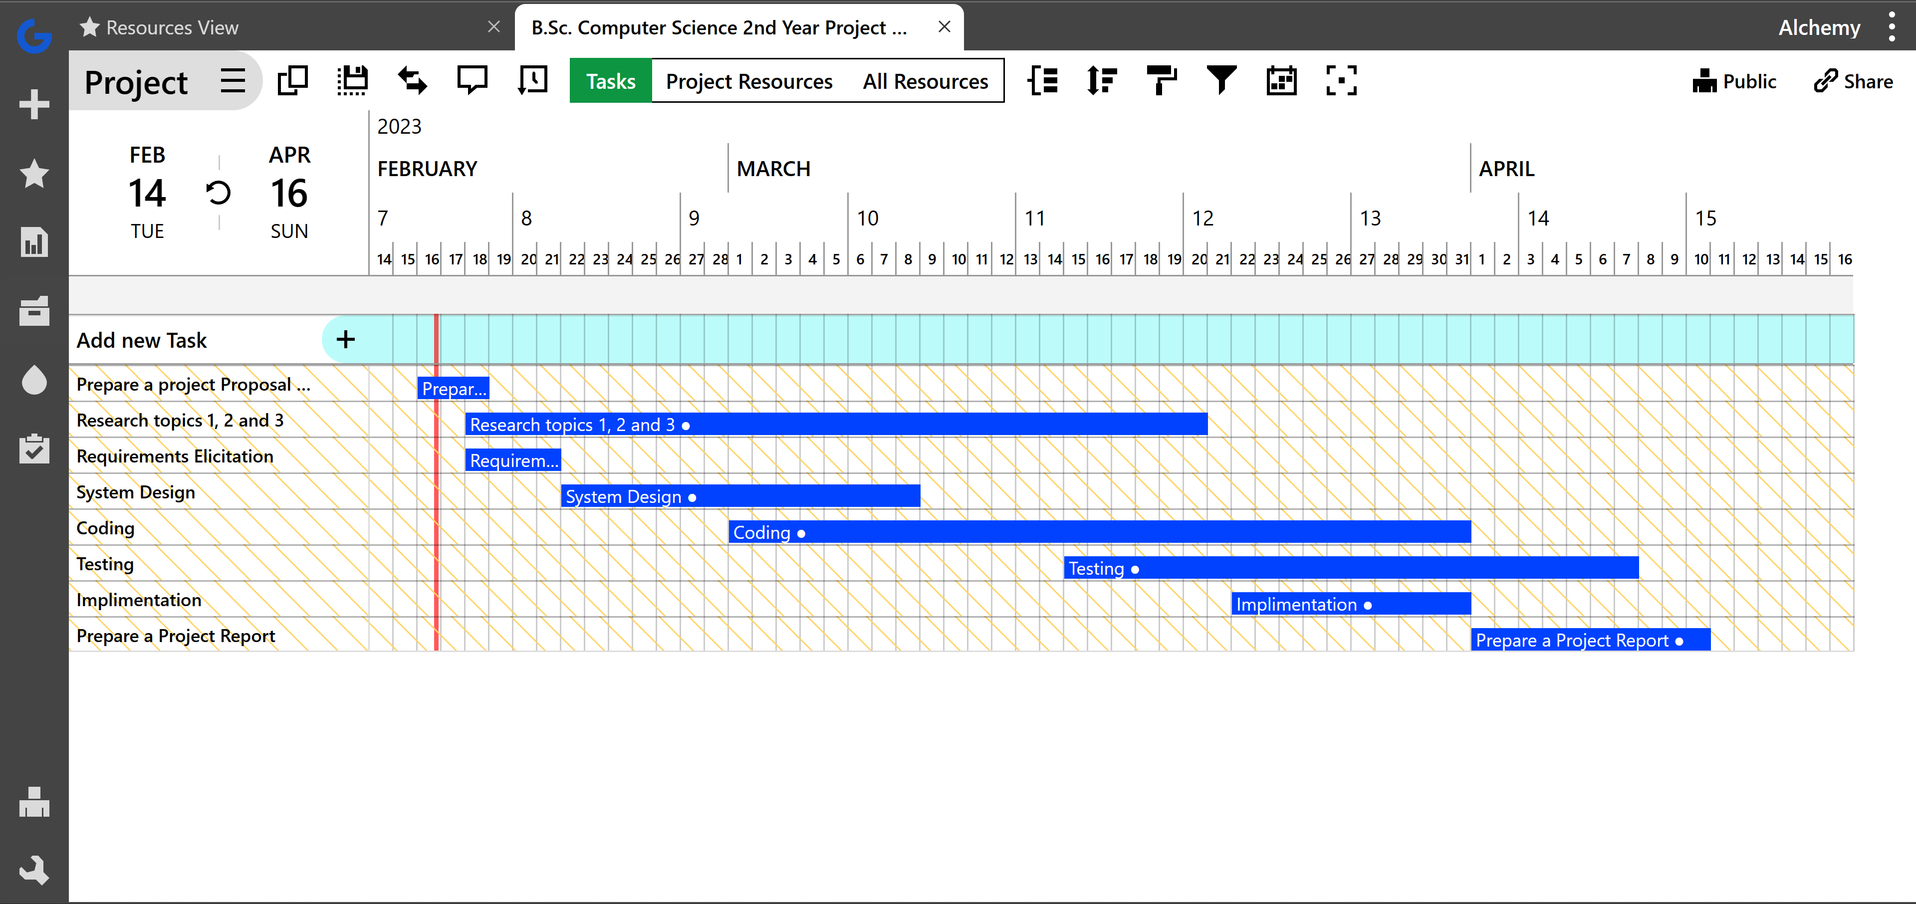PROJECT GANTT CHART